# Summary

|  |  |  |  |  |
| --- | --- | --- | --- | --- |
| Syntax Features | Source Code From | | | |
| In-class demos | Referenced PHP tutorials | Homework exercises or personal practice | Assessment |
| 1. PHP tags, escaping html, Instruction separation |  |  |  |  |
| 2. Variables: basic types, globals, scope, predefined variables, constants |  |  |  |  |
| 3. Namespaces, include, require |  |  |  |  |
| 4. Coding Conventions |  |  |  |  |
| 5. Arrays, foreach |  |  |  |  |
| 6. Selection |  |  |  |  |
| 7. Iteration |  |  |  |  |
| 8. Functions |  |  |  |  |
| 9. Strict types, type hinting, |  |  |  |  |
| 10. Classes, properties, constructors and destructors, visibility |  |  |  |  |
| 11. OO “tricks”: inheritance, static, abstract, interfaces |  |  |  |  |
| 12. Error handling, try, catch, throw, finally |  |  |  |  |
| 13. Cookies |  |  |  |  |
| 14. Sessions |  |  |  |  |
| 15. REST |  |  |  |  |
| 16. Passwords |  |  |  |  |
| 17. Regular expressions |  |  |  |  |
| 18. il8n |  |  |  |  |
| 19. String functions |  |  |  |  |
| 20. MySQL Improved Extension |  |  |  |  |

# PHP tags, escaping html, Instruction separation

## 1.1 In-class demo

**PHP tags & escaping html**

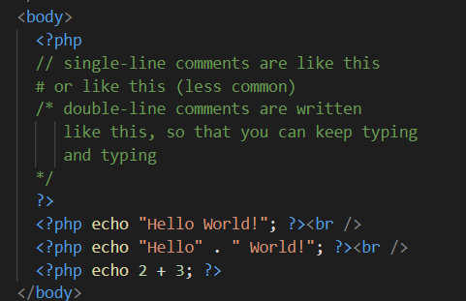

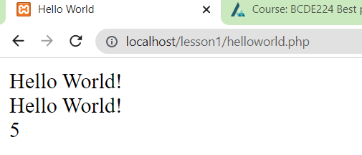

## 1.2 Referenced PHP tutorials

<https://www.php.net/manual/en/language.basic-syntax.phptags.php>

**PHP tags short echo tag**

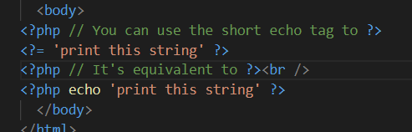

## 1.3 Homework exercises or personal practice

**Basic php tags, short echo tag, instruction separation with end tag and semi colon and escaping html**

## 1.4 Assessment

# Variables: basic types, globals, scope, predefined variables, constants

## 2.1 In-class demo

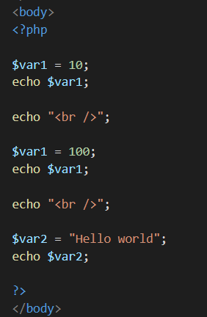

## 2.2 Referenced PHP tutorials

<https://www.php.net/manual/en/language.types.intro.php>

**Basic Types**

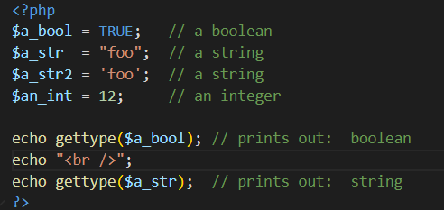

## 2.3 Homework exercises or personal practice

**Globals, predefined variable, const**

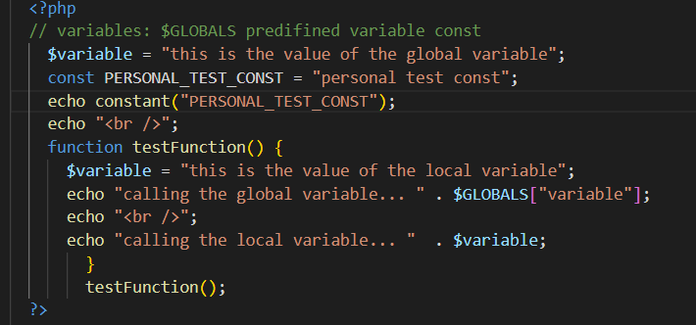

## 2.4 Assessment

# 3. Namespaces, include, require

## 3.1 In-class demo

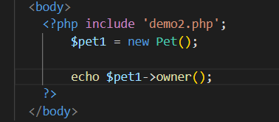

**Demo2.php**

## 3.2 Referenced PHP tutorials

<https://www.php.net/manual/en/language.namespaces.php>

**Namespace and include**

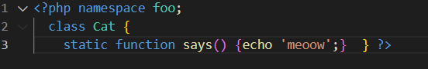

## 3.3 Homework exercises or personal practice

**Require, namespace**

**require_php_test.php file**

## 3.4 Assessment

# 4. Coding Conventions

## 4.1 In-class demo

**Must always use <?php or <?= tags. Class use StudlyCase and methods use camelCase**

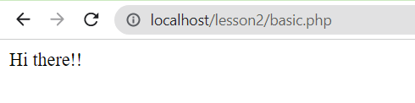

## 4.2 Referenced PHP tutorials

<https://www.php-fig.org/psr/psr-1/>

**NameSpace must uses $StudlyCase. Constants must use UPPERCASE_AND_UNDERSCORE**

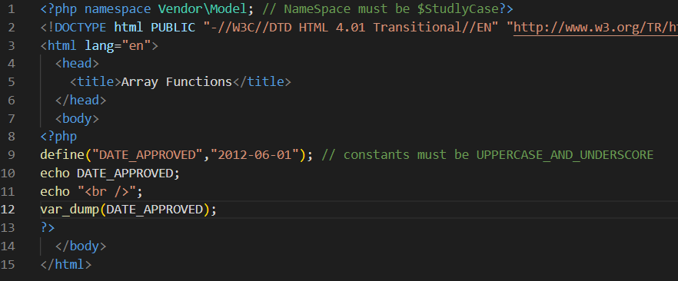

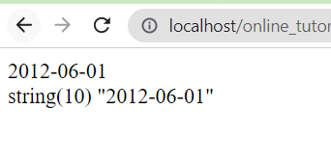

## 4.3 Homework exercises or personal practice

**Constants should be UPPERCASE with _underscore**

**Namespace and class should be $StudlyCase, $camelCase for methods / functions**

## 4.4 Assessment

# 5. Arrays, foreach

## 5.1 In-class demo

**After php 5.4 array without array() and foreach method just values**

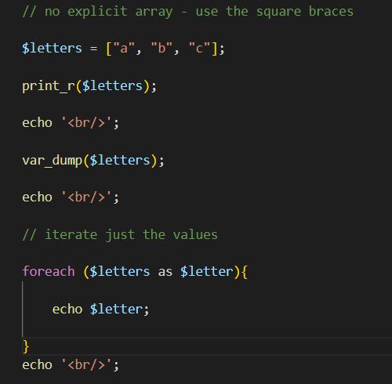

## 5.2 Referenced PHP tutorials

<https://www.php.net/manual/en/control-structures.foreach.php>

**Array use array() modify array with foreach method with value assigned by reference using &**

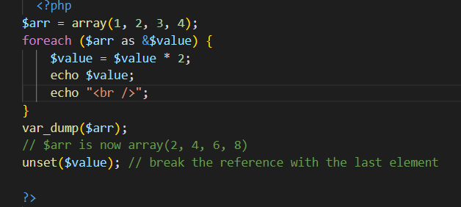

## 5.3 Homework exercises or personal practice

## 5.4 Assessment

# 6. Selection

## 6.1 In-class demo

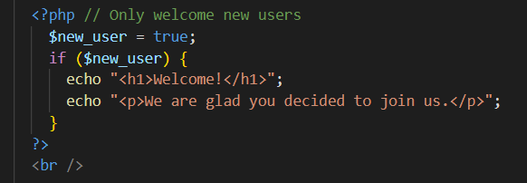

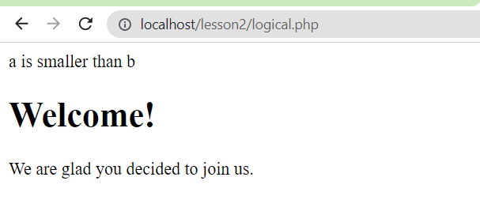

## 6.2 Referenced PHP tutorials

<https://www.php.net/manual/en/control-structures.elseif.php>

**Elseif selection statement**

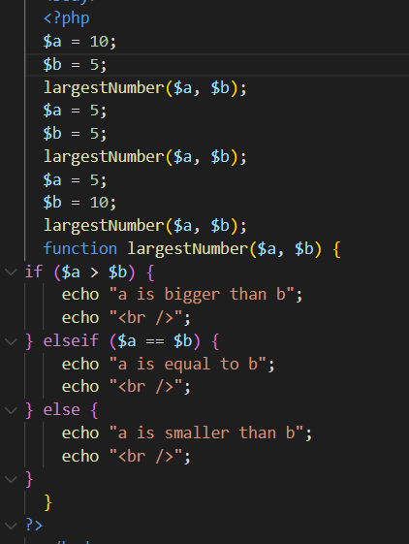

## 6.3 Homework exercises or personal practice

**Switch statement**

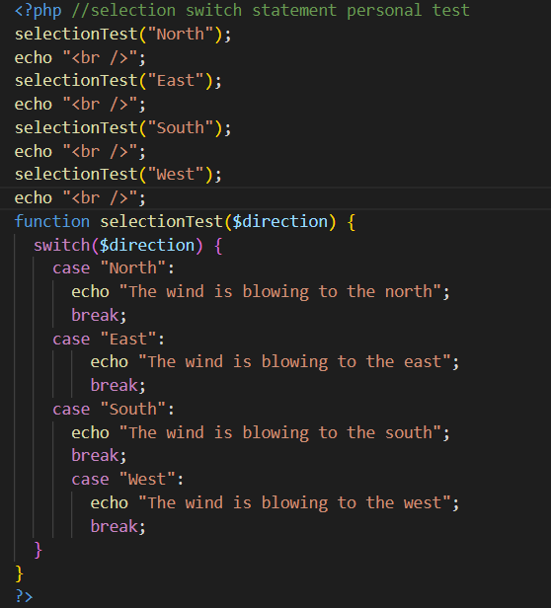

## 6.4 Assessment

# 7. Iteration

## 7.1 In-class demo

**For loop**

## 7.2 Referenced PHP tutorials

<https://www.php.net/manual/en/control-structures.while.php>

**While loop**

## 7.3 Homework exercises or personal practice

**While continue and goto**

**The while loop was completed.**

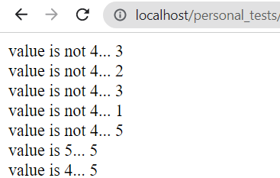

**While loop was skipped using goto.**

## 7.4 Assessment

# 8. Functions

## 8.1 In-class demo

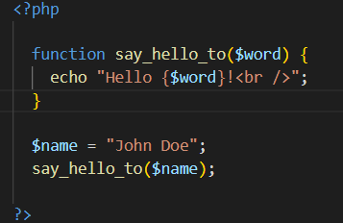

## 8.2 Referenced PHP tutorials

<https://www.php.net/manual/en/functions.arrow.php>

**Arrow Function**

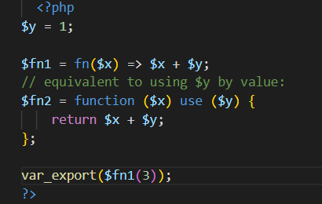

## 8.3 Homework exercises or personal practice

**Assigning variable to anonymous function (a function without a name)**

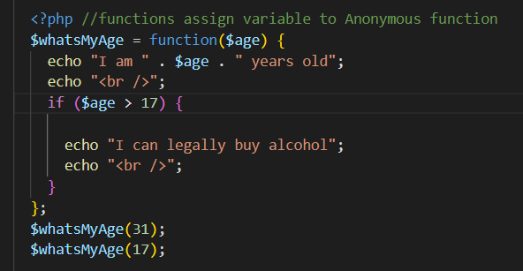

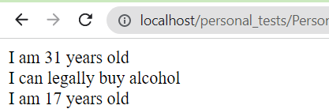

## 8.4 Assessment

# 9. Strict types, type hinting,

## 9.1 In-class demo

**Throws fatal error as return value is stating its string but passed value is int.**

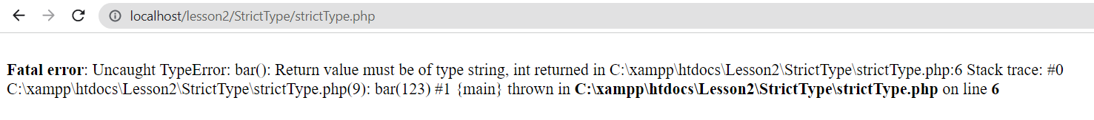

**When changed to function returns: int**

## 9.2 Referenced PHP tutorials

<https://www.php.net/manual/en/language.types.declarations.php#:~:text=Strict%20typing%20%C2%B6,on%20a%20per%2Dfile%20basis>.

**Declare Strict types var dump int then var dump float for declared type int**

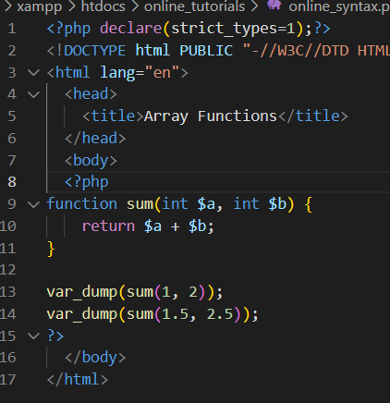

**Fatal error on second var_dump as values parsed are float, when int type is declared in parameters.**

## 9.3 Homework exercises or personal practice

**Strict types parameters and function return type of string throw error when passing int.**

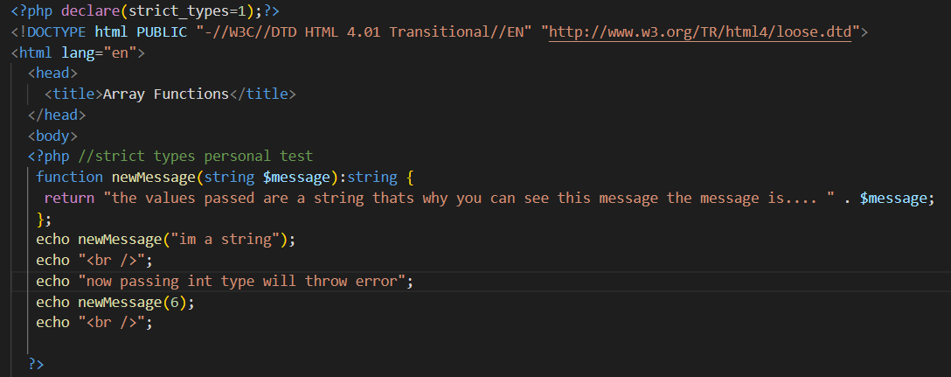

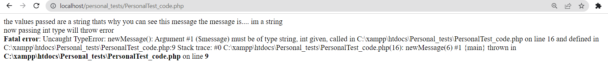

**Setting return to a int type throws a fatal error as function has declared return value of a string**

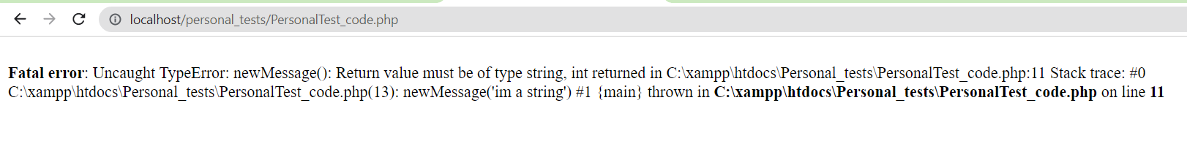

## 9.4 Assessment

# 10. Classes, properties, constructors and destructors, visibility

## 10.1 In-class demo

**Class person with private property and a protected property being used by child (Pet) that’s inherited from Person. Public function within Pet class.**

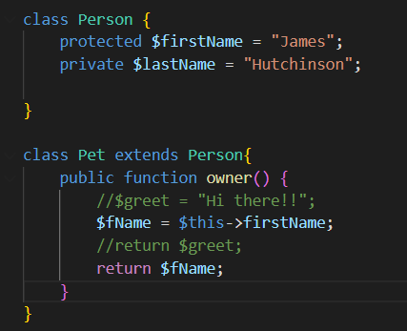

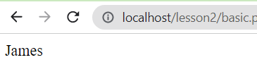

## 10.2 Referenced PHP tutorials

<https://www.php.net/manual/en/language.oop5.decon.php>

**Destructor**

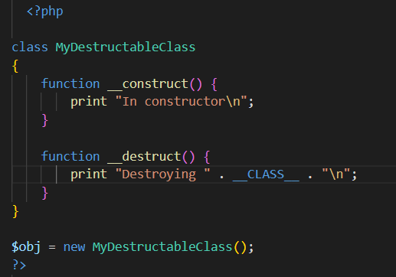

## 10.3 Homework exercises or personal practice

**Classes visibility public, protected and private**

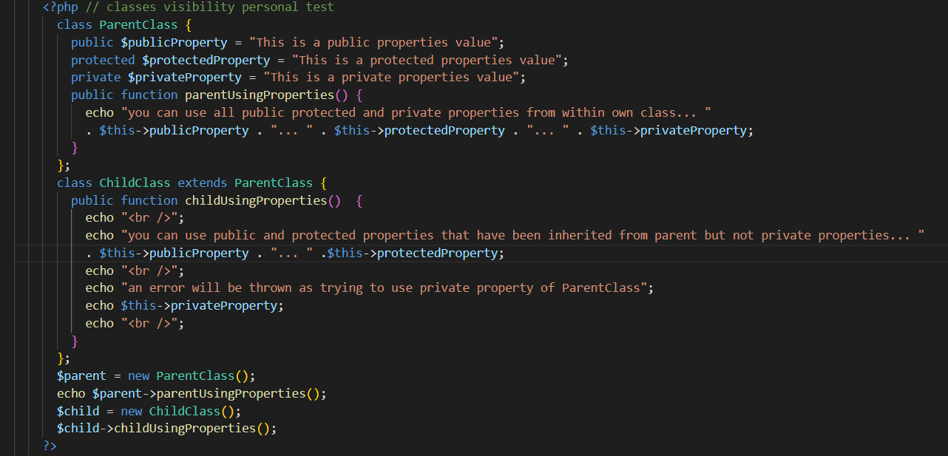

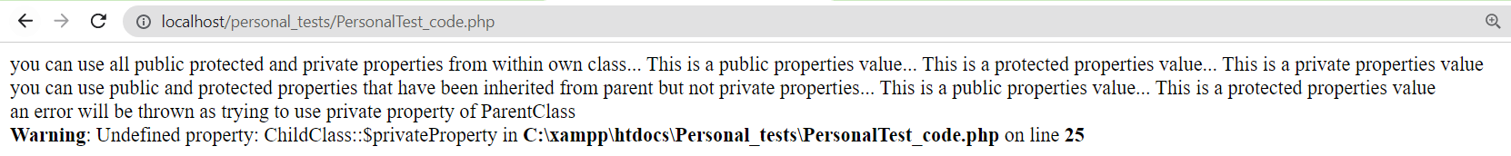

## 10.4 Assessment

# 11. OO “tricks”: inheritance, static, abstract, interfaces

## 11.1 In-class demo

**Inheritance can inherit protected or public properties/methods**

## 11.2 Referenced PHP tutorials

<https://www.php.net/manual/en/language.oop5.interfaces.php>

**Interface constants can be overridden after PHP 8.1.0**

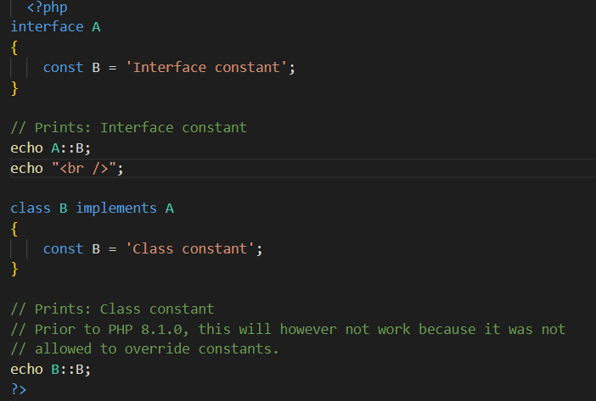

## 11.3 Homework exercises or personal practice

**Class static calls vs non static calls**

## 11.4 Assessment

# 12. Error handling, try, catch, throw, finally

## 12.1 In-class demo

## 12.2 Referenced PHP tutorials

<https://www.php.net/manual/en/language.exceptions.php>

**Throw, catch, try and finally**

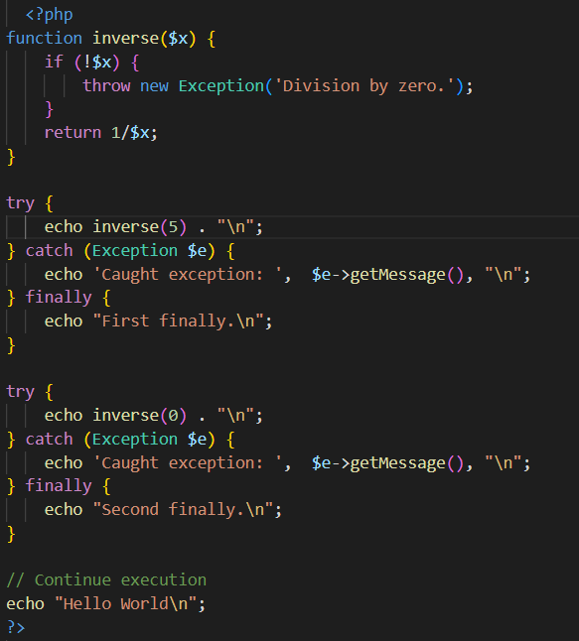

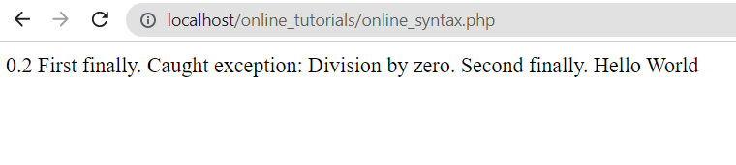

## 12.3 Homework exercises or personal practice

## 12.4 Assessment

# 13. Cookies

## 13.1 In-class demo

## 13.2 Referenced PHP tutorials

<https://www.php.net/manual/en/function.setcookie.php>

**setcookie() and send example**

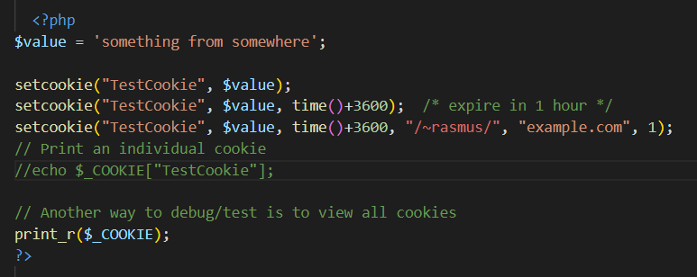

## 13.3 Homework exercises or personal practice

## 13.4 Assessment

# 14. Sessions

## 14.1 In-class demo

## 14.2 Referenced PHP tutorials

<https://www.php.net/manual/en/session.examples.basic.php>

**Registering a variable with $_SESSION**

**Refreshed the browser 6 times it incremented by 1 every time I did**

## 14.3 Homework exercises or personal practice

## 14.4 Assessment

# 15. REST

## 15.1 In-class demo

## 15.2 Referenced PHP tutorials

<https://www.php.net/manual/en/function.header.php>

**Header**

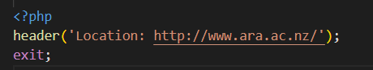

**Redirected to Ara website**

<https://www.php.net/manual/en/reserved.variables.server.php>

**Get server name**

## 15.3 Homework exercises or personal practice

## 15.4 Assessment

# 16. Passwords

## 16.1 In-class demo

## 16.2 Referenced PHP tutorials

## 16.3 Homework exercises or personal practice

## 16.4 Assessment

# 17. Regular expressions

## 17.1 In-class demo

## 17.2 Referenced PHP tutorials

## 17.3 Homework exercises or personal practice

## 17.4 Assessment

# 18. il8n

## 18.1 In-class demo

## 18.2 Referenced PHP tutorials

## 18.3 Homework exercises or personal practice

## 18.4 Assessment

# 19. String functions

## 19.1 In-class demo

## 19.2 Referenced PHP tutorials

## 19.3 Homework exercises or personal practice

## 19.4 Assessment

# 20. MySQL Improved Extension

## 20.1 In-class demo

## 20.2 Referenced PHP tutorials

## 20.3 Homework exercises or personal practice

## 20.4 Assessment